Practical Week-8
Task 1: Develop a program using malloc(), calloc(), realloc(), and free(). Monitor memory allocation behavior and identify memory leaks using Valgrind.
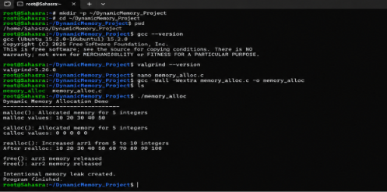
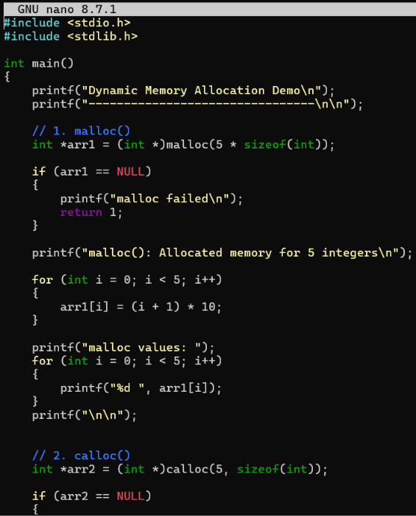
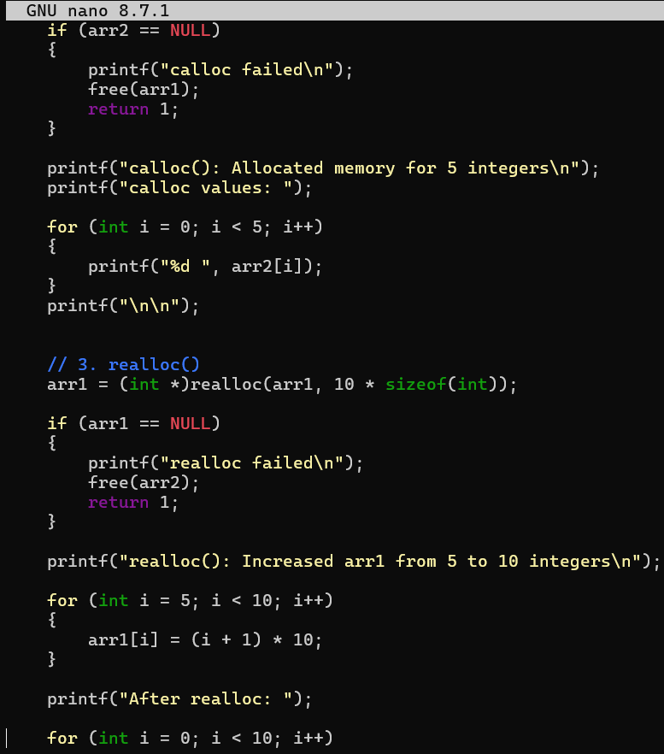
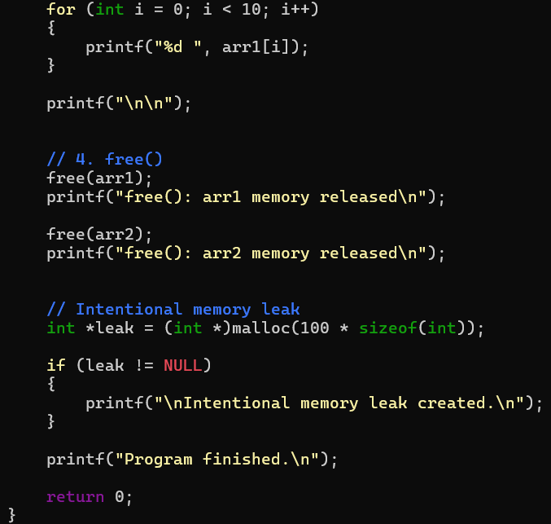
Task 2: Develop a program that demonstrates Copy-on-Write behavior after a fork(). Analyze memory usage before and after modifying data in the child process.
